|  |  |  |  |  |  |
| --- | --- | --- | --- | --- | --- |
|  |  | | | |  |
|  | Philadelphia University | | | |  |
| Faculty of Pharmacy | Department of Pharmaceutical Sciences | | | |  |
| Drug Design | | 0510412 | |  | |
| Lecturer: Dr. Bilal Al-Jaidi | |  | |  | |
| Student name: | | | Registration no.: | | |

Question-1:

The discovery of tolbutamide was done based on the fact that carbutamide (antibacterial agent) has hypoglycaemic side effect, explain that with selecting the pharmacophoric groups in both structures (the hypoglycaemic and the antibacterial pharmacophore):



..................................................................................................................................................................

..................................................................................................................................................................

..................................................................................................................................................................

Question-3

Define the followings:

1. Homologation:
2. Auxophoric group:
3. Drug candidate

Question-3:

Calculate the logP for Metaprotenol using the table of fragments below (the experimental logP is 1.8):



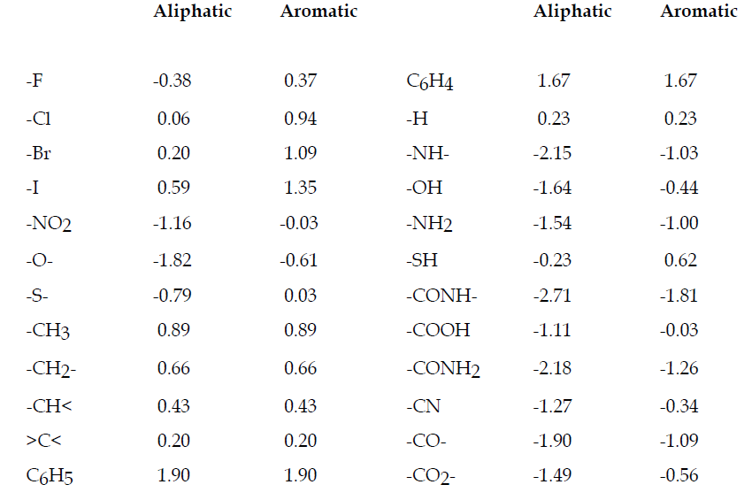

..................................................................................................................................................................

..................................................................................................................................................................

..................................................................................................................................................................

..................................................................................................................................................................

..................................................................................................................................................................

..................................................................................................................................................................

Question-4:

Sulfamethoxazole is an antibacterial agent; both the ionized and unionized forms are important for its pharmacokinetic and pharmacodynamic properties, explain?



........................................................................................................................................................................................................................................................................................................................................................................................................................................................................................................................................................................................................................................................................

Question-5:

You have the following two drug concentration-response curves, one for agonist in presence of competitive antagonist, the other for agonist in presence of non competitive antagonist, which is which, explain your answer:

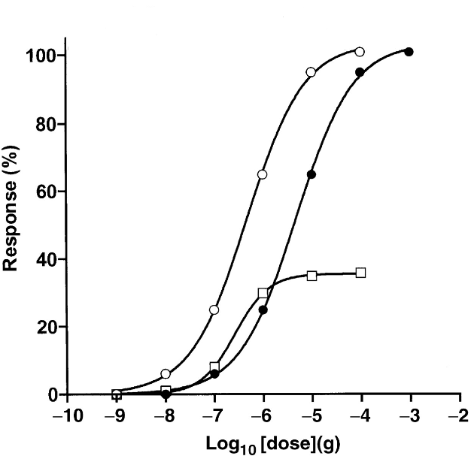

**Agonist alone**

**Curve B**

**Curve A**

..................................................................................................................................................................

..................................................................................................................................................................

..................................................................................................................................................................